Part 1

Case Study 2

OrderData (*Order Num*, Line, *Item Number*, Qty Ordered, Price Each)

Item (Item Number, Description)

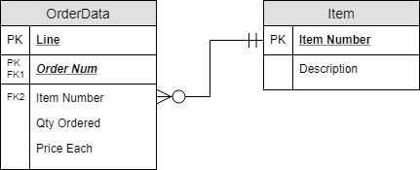

Case Study 3

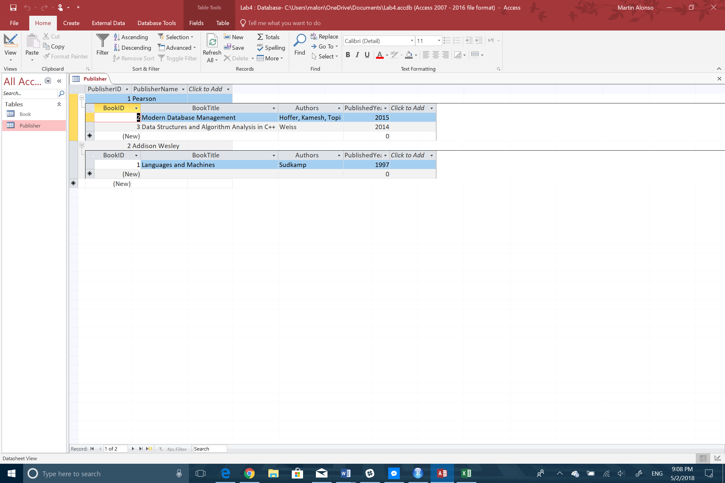

Part 2 – Normalizing Video Data for VidCast

VidCast (Video, Video Title, *User Name*, Stream Start, Duration, *Content Rating*)

User (User Name, User Tier, Min Tier Followers)

Rating (Content Rating, Rating Description)

